iMind Lesson on Multiple Intelligences
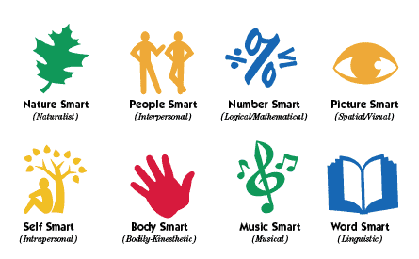

- My three strongest intelligences are:

1.
2.
3.

- My three favourite subjects are:
1.
2.
3.
- Draw arrows which link your strongest intelligences with your favourite subjects.

- My two weakest intelligences are:
1.
2.
- My two least favourite subjects are:
1.
2.

- Using the grid below write/type your three strongest i9ntelligences along the top row and your two weakest intelligences in the left hand column. Then give examples in the reaming boxes of how you might use your strong intelligences to develop your weaknesses in learning situations.

 | Strong intelligence 1: | Strong intelligence 2: | Strong intelligence 3:
Weaker intelligence 1:
Weaker intelligence 2:

